FAO all pharmacies delivering the Meningitis-B time-limited vaccination programme for young adult – please read and action ASAP
PLEASE NOTE – all pharmacies expecting a delivery on Friday, please be aware that action may required from you ahead of a deadline of 8am Wednesday 15th July.

** This guidance has been created at speed to ensure that pharmacies have the information as soon as possible in order to act on this before the deadline. Please accept our apologies in advance for any errors, and please be aware that further updates may follow**
Thank you for all of your efforts in preparing for the first Meningitis B vaccinations for young adults, starting from Monday 20th July.
Many sites will have had their first doses of Men-B vaccine delivered, or will be expecting a delivery in the coming days.
Details on how to check these details are further down the email

For all pharmacies who have a Friday delivery day:

- Your allocation (the volume of vaccine that you can order) for delivery may have increased, depending on the level of booked appointments you have. Until 8am tomorrow, Wednesday 15th July, if you have an increased allocation, you have the opportunity to modify your existing order to increase the volume delivered to your pharmacy this Friday 17th July. Please check and modify your order ASAP if required.

For all pharmacies who have a Monday to Thursday delivery day:

- Any order you have placed can unfortunately no longer be modified for this week. Please ensure that you place an order for delivery next week (17th July onwards) to ensure you have sufficient vaccine to manage your booked appointments.

ALL pharmacies
The onus is on pharmacies to manage their bookings in line with supply. Please review your MYA bookings and calendars to make sure that you have sufficient vaccine to manage your booked activity up to the point at which your next delivery will be due.
- If you have booked appointments which will exceed the volume of vaccine you have, please reschedule these bookings, or ask the individual to rebook at another participating pharmacy which has supply
- At such time as your booked appointments come close to the volume of vaccine you have, please close availability until after your next scheduled delivery day.

To check your order delivery day, navigate to the “Supply Dashboard” on the Federated Data Platform
Click on “Site Information & Stock”, highlighted below: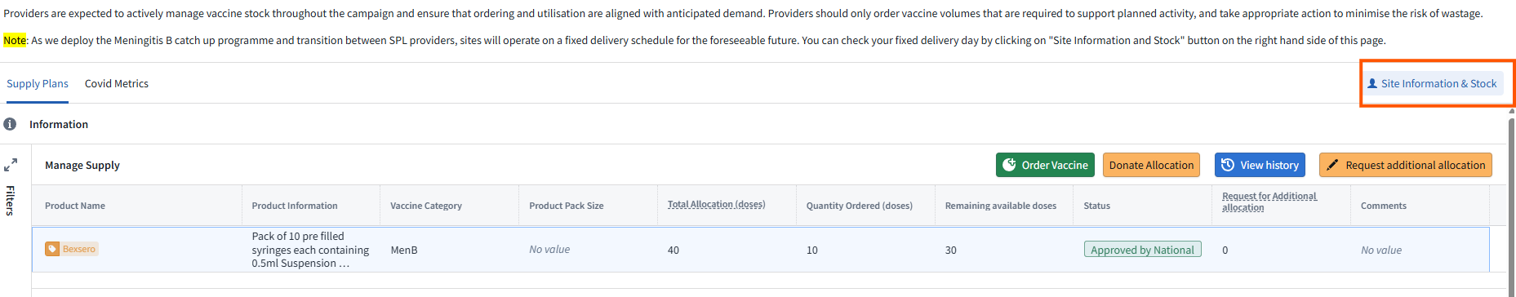
An additional screen will open, and you will be able to see your delivery day in the highlighted cell below.
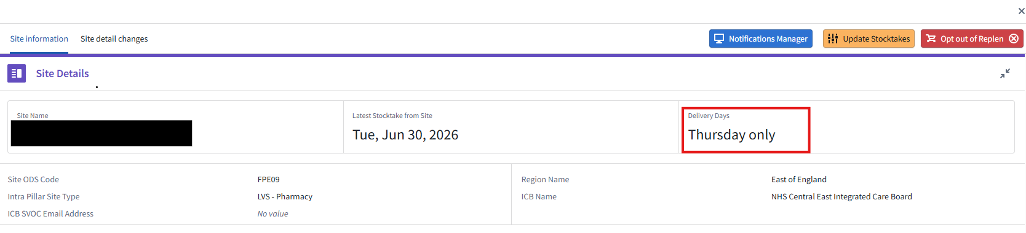
To modify your order
The example below shows a pharmacy who has had an increase to their available vaccine and could modify their order.
- Total allocation – reflecting how much vaccine is available for the pharmacy to order
- Quantity ordered – reflecting how much has been ordered to date
- Remaining available doses – reflecting how much is still available for the pharmacy to order from
- Order process Date/Status – the order process date is the last time at which the existing order can be modified. This example shows the order status as “Requested” which means that it can still be modified. Once the order process date/time is passed, the order status will change to “Approved” and no further changes can be made.
- Modify Order – if the status of the order is still “Requested”, clicking this button will open a menu which will allow the user to increase/decrease the number of doses ordered (in multiples of 10) up to the limit of the available allocation (as displayed in “1”). Changes to the delivery date can also be made here, to change the delivery to the same week day on a different week.
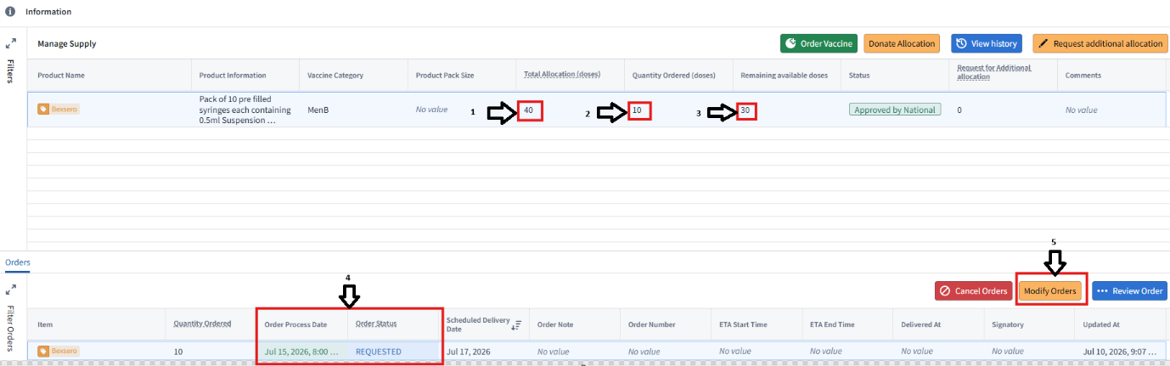
Please contact your ICB team or england.eoe-vacprg@nhs.net for any further support.

