Face to workshops

We still have some spaces for our upcoming full day workshops taking place in the region which aim to update key clinical assessment and examination skills and include a guest medical speaker.

- Respiratory clinical assessment skills Sunday 17th May, Welwyn
- NHS Pharmacy First clinical assessment and examination skills Sunday 12th July, Welwyn

- Menopause: prescribing perspectives

Workshops for our new topic on the menopause have now gone live for booking. Pharmacies are increasingly the first point of contact for people seeking support with menopause symptoms. By enhancing clinical reasoning, promoting shared decision making and strengthening consultation skills, this Menopause prescribing perspectives programme equips pharmacists and pharmacy technicians to confidently support women through perimenopause and menopause across a wide range of practice settings.
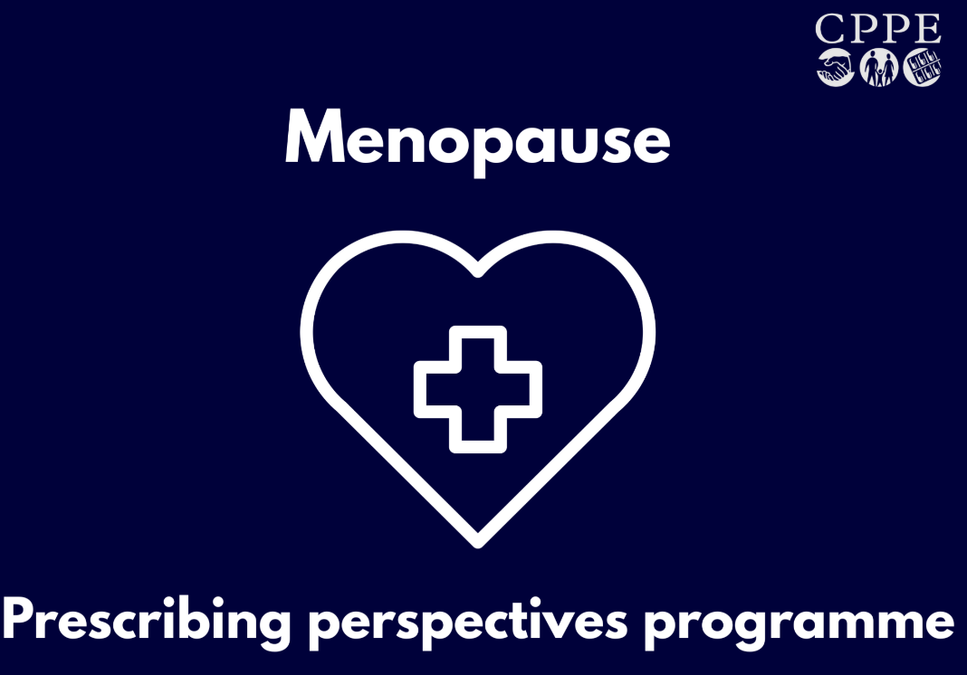

7 June - Colchester
23 June – Norwich
28 June – Cambridgeshire
8 July - Ipswich
17 September - Chelmsford
22 September – Flitwick, Bedfordshire
28 September – Diss, Norfolk

- Optimising inhaler technique: improving outcomes – workshop, 17th June, Hatfield

We have a further opportunity for inhaler training in the region with a workshop taking place in Hatfield, Hertfordshire on June 17th from 7-9pm. This is a useful learning opportunity for pharmacy technicians, including those taking part in our Pharmacy Technician Development Programme: preparing for the future. It is also suitable for trainee pharmacists or newly qualified pharmacists to attend or those who just want to refresh their knowledge and skills around inhaler technique.

Did you know? - Baverstock et al concluded ‘…only eight percent of healthcare professionals could demonstrate all stages of MDI use correctly.’ Whilst this data is old, how many pharmacy professionals today could demonstrate all stages of an MDI or DPI correctly?

Reference: Baverstock M, et al. Do Healthcare Professionals have sufficient knowledge of inhaler techniques in order to educate their patients effectively in their use? Thorax 2010; 65:pA117 (poster).

Book at https://www.cppe.ac.uk/programmes/l/inhalers-w-03/

New learning programmes

Type 2 diabetes: Optimising safe and personalised management is a new Optimise programme designed for pharmacists, pharmacy technicians and trainee pharmacists working in hospital and general practice settings. This programme assumes clinical knowledge and creates space to apply it. Type 2 diabetes management continues to evolve, with updated NICE medicines guidance published in February 2026. Pharmacy professionals are increasingly asked not just what to supply, but when, why and how, to personalise treatment decisions. Optimise sessions create space for thoughtful discussion, shared learning and practical insight from colleagues. Participants leave with practical next steps, greater confidence and a clearer approach to shared decision making.

Fundamentals of neurology e-course. In your role within pharmacy, you can provide key support to people living with neurological conditions. We know that many of you want more confidence in recognising symptoms, applying evidence-based guidance and supporting safe transfer of care. The course opens with an exploration of neurology and the impact of neurological conditions. Then you’ll learn about covert administration, the Mental Capacity Act, advanced care planning and more. Six further units focus on specific conditions. Choose the topics that meet your learning needs:
- Migraine
- Epilepsy
- Stroke
- Acquired brain injury
- Myasthenia gravis
- Motor neurone disease

Digital health and clinical informatics – an introduction

Digital skills are becoming essential across every area of pharmacy practice, and the new CPPE e-learning has been developed to support this shift. This programme offers a practical and structured introduction to the digital systems that shape everyday care, helping pharmacy professionals understand how these systems interact and how they influence patient outcomes. Learners explore the digital ecosystem across community, hospital, general practice, and health and justice settings. Through real examples, including video and audio stories from pharmacy teams and members of the public, the programme brings to life how digital solutions support care and decision-making.

PGDs: Empowering pharmacy technicians to provide services online workshops

We are offering further online workshops to support pharmacy technicians with confidently expanding their role.

Primary Care Pharmacy Education Pathway (PCPEP)

The next cohort starts in May 2026 and is open for booking. Register here. To find out more about the Primary Care Pharmacy Education pathway click here

- Pharmacy technician development programme: preparing for the future.

We still have spaces on this programme.

It is designed to help pharmacy technicians build confidence in clinical, leadership and decision-making skills, with a strong emphasis on adapting to the expanding scope of pharmacy technician practice. This includes supplying and administering medicines under Patient Group Directions such as the October 2025 expansion of the Pharmacy Contraception Service, and evolving requirements under the NHS Pharmacy First scheme. It will also be adapted to include learning on the pending supervision legislation changes.

Celebrating diversity

Every month, we publish an article on the CPPE news page of our website, celebrating diversity and highlighting how forthcoming celebrations, festivals or observances can impact on pharmacy practice. The May 2026 cultural and identity-linked celebrations, observances and awareness days include Mental health awareness week, Deaf awareness week, and key dates in the Christian, Islam, Judaism and Jainism faiths. The May article will be published soon.

CPPE Pharmacy conversations – New episode available

In this latest episode, we are joined by joined by Karen Baxter (deputy CEO, RPS) and Geraldine McCafferty (director for Wales, RPS) to explore one of the most significant developments for the profession in recent years – the Royal Pharmaceutical Society’s transformation into the Royal College of Pharmacy.
After recounting their professional journeys, our guests reflect on change behind the scenes at the RPS, and what it will mean for members across the UK.

Community Pharmacy and General Practice Conference,

CPPE is contributing to the Programme Advisory Committee for a new national conference uniting community pharmacy and general practice - 21-22 June, National Conference Centre, Birmingham and the agenda outline has now been released. Brought together with the National Pharmacy Association (NPA), the free event will convene community pharmacists, GPs, nurses, practice managers, PCN leaders and ICB representatives for two days focused on practical collaboration between community pharmacy and general practice.
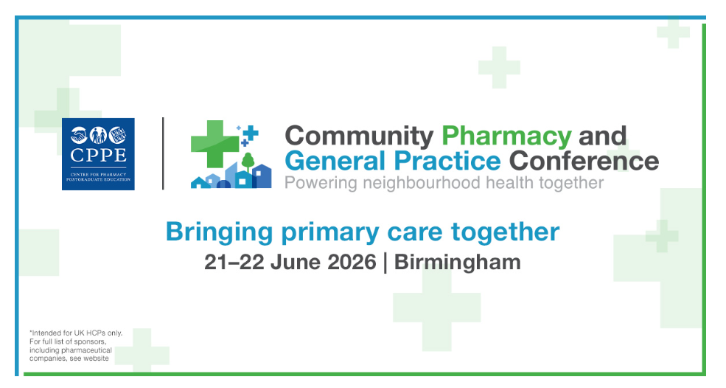

CPPE partners with the Clinical Pharmacy Congress (CPC) 8-9 May 2026
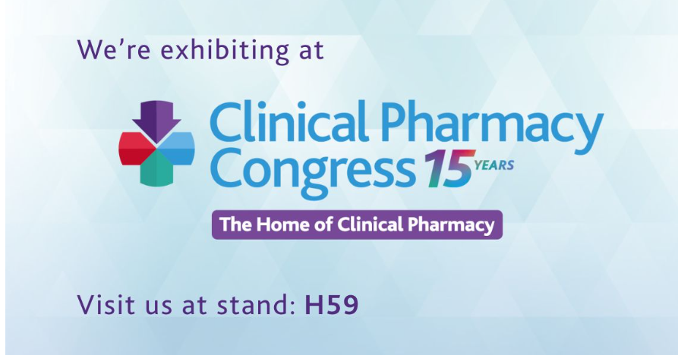

CPPE is delighted to return to CPC. Join us at stand H59 to explore how we can support your development at every stage of your career.
Visit us to discover:
- our full range of learning courses and pathways
- resources designed to strengthen consultation skills, clinical decision making and person-centred practice
- support for pharmacists and pharmacy technicians navigating new roles and responsibilities
- guidance on planning your learning journey and developing your career
Whether you’re just starting out, looking to specialise, or stepping into leadership, our team will be on hand to help you identify the right next step.

