Creating CPCS Toolbar shortcut icon

- Right click on an empty space in the top part of the screen where the toolbar icons are. Then select ‘Configure Toolbar.’
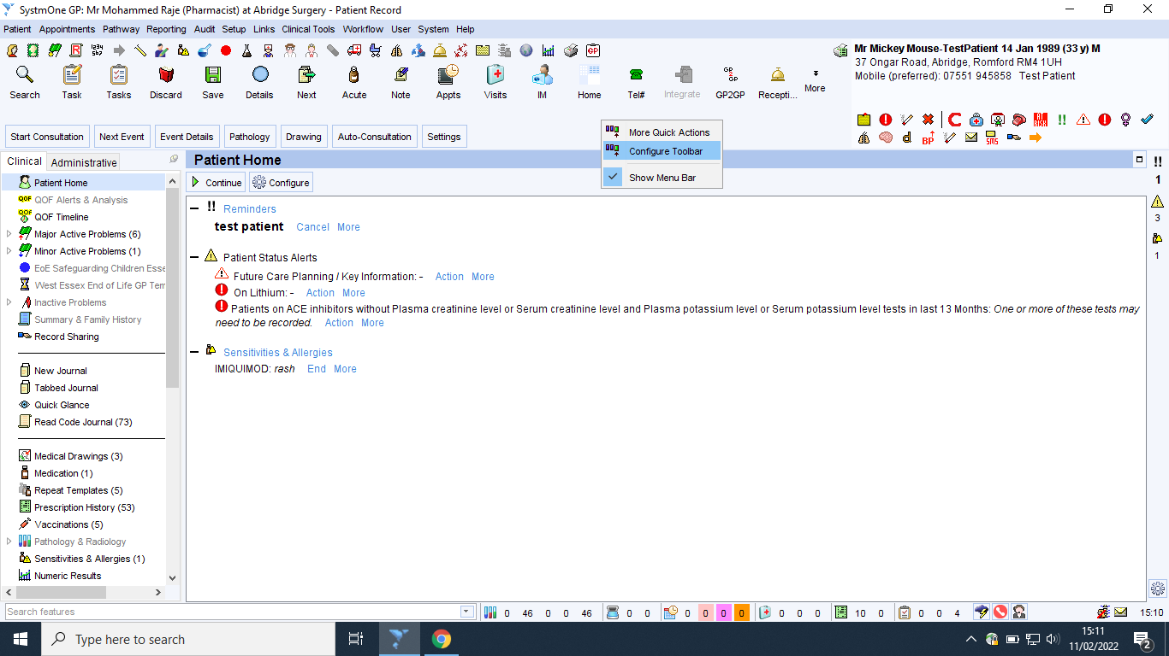

- Select whether you would like to add the button to the larger icons or the smaller icons in the toolbar (I normally select the larger icons). Once you have decided then select ‘Amend Button Set.’
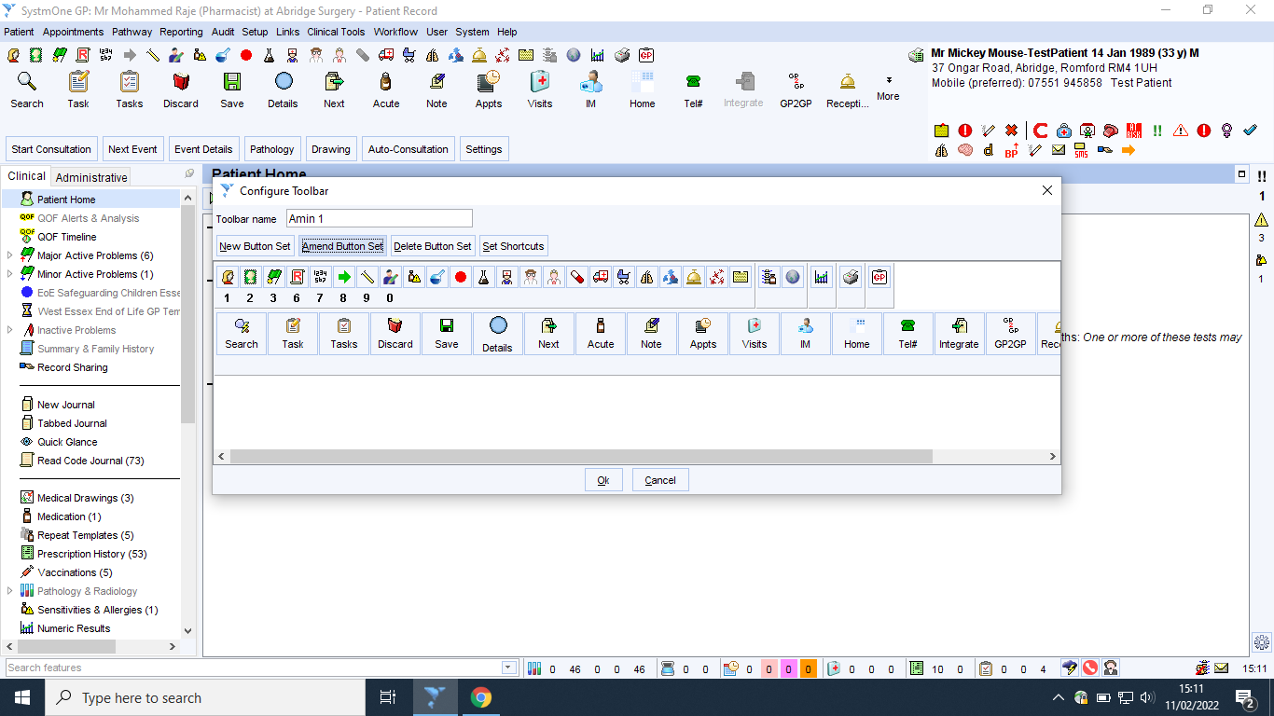

- In the pop up window, on the top left hand side there will be a search feature. In the search bar if you type in ‘CPCS’ then ‘Community Pharmacy Services’ icon comes up. Click it once and then press the ‘+’ which is on the middle of the window. You will not see it on the right hand side. Press ‘Ok’ and you will see the CPCS icon added to your toolbar.
